Title of abstract in Arial, Font size: 14, Bold, centered

Author names Arial, Font size: 12, Regular, centered
Lastname, A.B.^{1*}, Lastname, A.B.²

Affiliation, address Arial, Font size: 10, centered example as in the following
² Department Name, Institution
*Presenting Author: e-mail@presenting.author

The main text, Arial, Font size: 11. Paragraphs are left justified. Page size is 21.6 cm x 28 cm, and margins are 25 mm on each side. References will be cited as [1].

The abstract is limited to one page and may include figures in TIFF or JPEG format; ensure high quality while keeping file size reasonable. The local organizing committee reserves the right to adjust formatting if necessary. Leave one blank line (14 pt) after the title, one blank line (12 pt) after the author list, two blank lines (11 pt) between affiliations and the start of the abstract text, and one blank line (11 pt) between paragraphs. The deadline for student award abstracts is April 1st, 2026, and for all other abstracts May 1st, 2026. Abstracts should be submitted as a DOC or DOCX file to abstracts.eprbiodose2026@gmail.com with the file name “EPRBioDose2026_abstract_surname_initial”. For student travel award submission: Use the subject line “EPRBioDose abstract –Student – surname” and include a letter of support from your supervisor stating the university affiliation and level/year of study in order to confirm student status. For Early Career Scientist travel award submission: Use the subject line “EPRBioDose abstract –ECS – surname”. For all other submissions: Use the subject line “EPRBioDose abstract – surname”. An abstract number will be assigned upon receipt. Please also indicate if you're applying for an oral presentation or a poster and designate in your email which category best fits your work (https://eprbiodose2026.org/conference-topic).
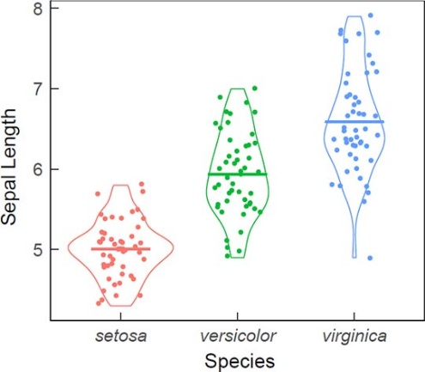

Figure 1. Figure legend goes here.
(Arial, font size: 11)
Participants submitting abstracts must be registered for the meeting by the deadline of the late registration, which will be July 30th, 2026. Presentations for which the presenting author is not registered will be automatically withdrawn after the deadline.

Keywords Maximum five (5) keywords separated by a semi-colon are to be given; Arial, Font size: 11. Leave one blank line (font size 11) between the main body of the text and the keywords.

References
1. Leave one blank line (font size 11) between the keywords and the references. References should follow the standards summarized in the NLM's Sample References (www.nlm.nih.gov/bsd/uniform_requirements.html) webpage and detailed in the NLM's Citing Medicine, 2nd edition (www.ncbi.nlm.nih.gov/books/NBK7256/). The reference list should be written out in full using Arial font size 10, example as in the following:
2. IAEA. Cytogenetic Dosimetry: Applications in Preparedness for and Response to Radiation Emergencies. Emergency Preparedness and Response (EPR-Biodosimetry). Vienna: International Atomic Energy Agency; 2011. 247 p.

